Full Paper Template for International Conference on Scientific Spirituality (20pt, bold-faced)

A. B. Author^{1,a)}, C. D. Author¹, and E. F. Author² (14pt)

¹ Department of ABCs, University, India (10pt, italic)
² Author’s Department, Affiliation, Country

a) Corresponding author: your@emailaddress.xxx
*Corresponding author (author@***.***)

Abstract
Page size is Letter, page borders are 2 cm wide. Title is in Times New Roman font 20pt size, bold, in cap/lower case, single-spaced, and centered at the head of the page. The authors are in Times New Roman font 14pt size, in cap/lower case, and centered. An empty line in 8pt follows the authors. The affiliation is in Times New Roman font 12pt size, italic, in cap/lower case, single-spaced, and centered. Use one 12pt empty line between the corresponding author and the text body. The name of the presenter should be in bold. The text body is in Times New Roman font 10pt size, in single column format, fully justified, and single-spaced. The bibliographic items are referenced as follows [1-4]. When referring to citations in the text, in square brackets [ ], show the number in order of appearance.

Keyword: At least four keywords separated by commas.
- Introduction
Authors shall adapt this template to the preparation of submission. The authors are recommended to prepare their manuscript in MS-Word format and submit both the original MS-Word file and its accompanying PDF file. The deadline for full paper submission is 10 August 2023 based on Indian Standard Time.
- Full paper Preparation
Papers should conform the following instructions.
2.1 Language
The full paper should be written in good English. It should have been carefully checked for clarity, conciseness, correctness of grammar, and typographical errors. For Hindi – the font should be Nirmala UI / Kokila
2.2 Length
8-10 pages are recommended for the full paper.
2.3 Figures
All photographs, charts and diagrams are to be referred to as "Figures". The preferred format for figure files is .jpg at a minimum resolution of 1200 dpi for lines, 600 dpi for greyscale and 400 dpi for color. Color art is free of charge for online publication. If figures will be printed in black and white, please ensure that the main information will be visible and do not refer to color in the text.
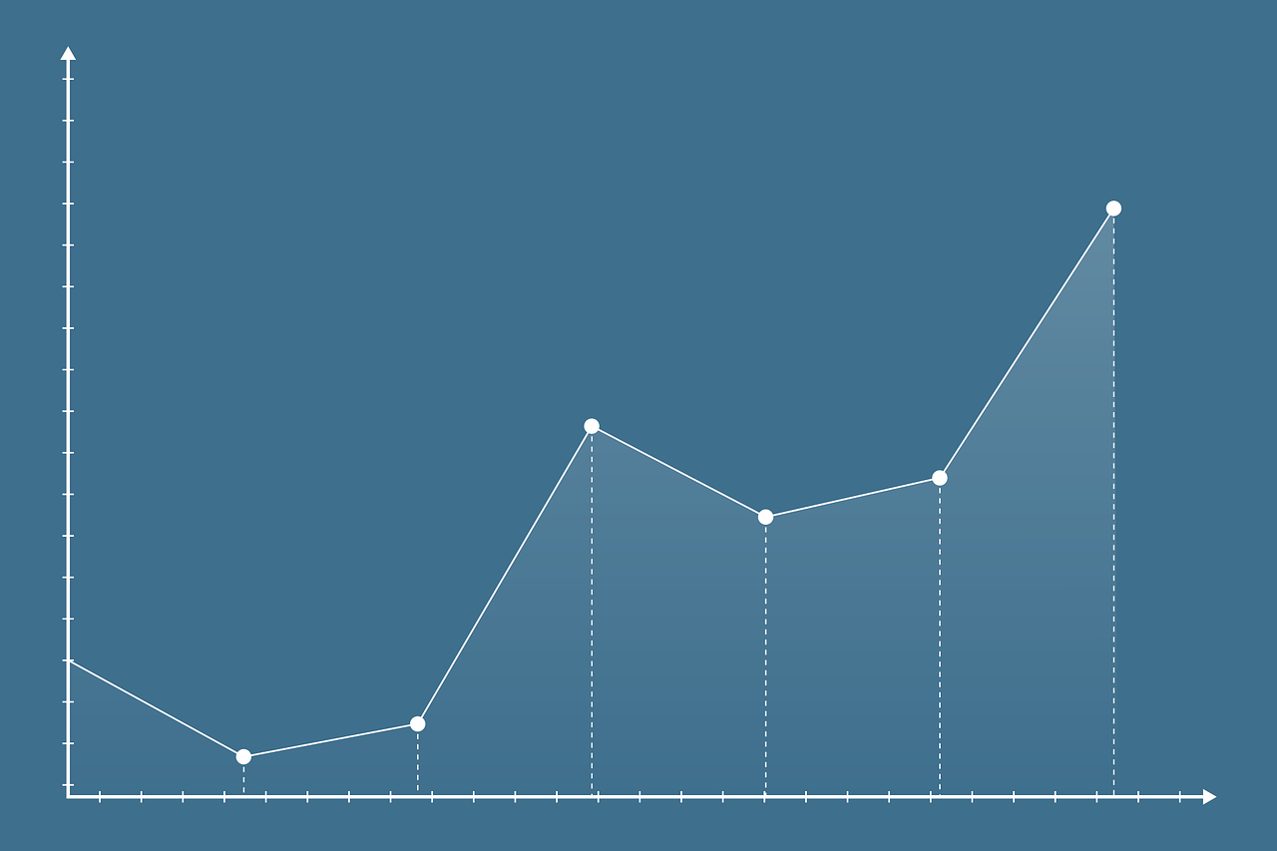
Fig. 1. The figure caption is in Times New Roman 10pt, bold, justified, and single-spaced.
2.4 Tables
Tables should be typed as part of the text, but in such a way as to avoid confusion with the text. Authors should try to ensure that a single table does not overlay on to the next page. All tables should have headings and be numbered.
Table 1 Table heading.
2.5 References
References should in Vancouver format. They should be indicated in square brackets according to the order of appearances in the text, i.e. [1], [2-4]. The full list should be collected at the end of the paper in numerical order. Total references are limited to 50 for Full Article and 30 for Notes. Articles can only be cited when published or in press.
Authors of references should be listed surname first, followed by a comma and initials of given names. All authors should be listed unless there are more than five, in which case only the first author should be given, followed by et al.
Titles of articles cited should be upright text, not italic, and in quotation marks. Book titles and journal titles are italic, but not in quotation marks. Do not use abbreviated journal titles. The publisher and city of publication are required for books cited.
References to websites should give authors if known, title of cited page, URL in full, and year of posting in paren-theses
Examples of layout of references are given below.
Journal Citation
See [1]
Book Citation
See [2].
Conference Citation
See [3].
Thesis/Dissertation Citation
See [4].
- Conclusions
CONCLUSIONS would be the last numbered, and required, section within the submission.

acknowledgement
Acknowledgements to all supports should be covered here, including financial support. But there should not be any kind of expression toward editors or reviewers.

REFERENCES

[1] A. B. Author, C. D. Author, Journal Title (2016);1(3):pp-pp.
[2] A. B. Author, Book Title. Edition. Place of Publication: Publisher name; Year. pp. 135-142.
[3] A. B. Author, Proc. of the ... Conference... Place of Publication: Publisher name; Year. pp. 45-52.
[4] A. B. Author, Thesis Title (Ph.D. thesis). Place of publication: University; Year.

